**GIMNASIO LOS PIRINEOS**

**“EDUCACIÓN Y FORMACIÓN INTEGRAL CON ENFASIS EN VALORES, INGLÉS, EMPRENDIMIENTO Y GESTIÓN LABORAL”.**

**TALLER III PERIODO**

**ENGLISH 10°**

ESTUDIANTE: ____________________________________ FECHA: __________________________

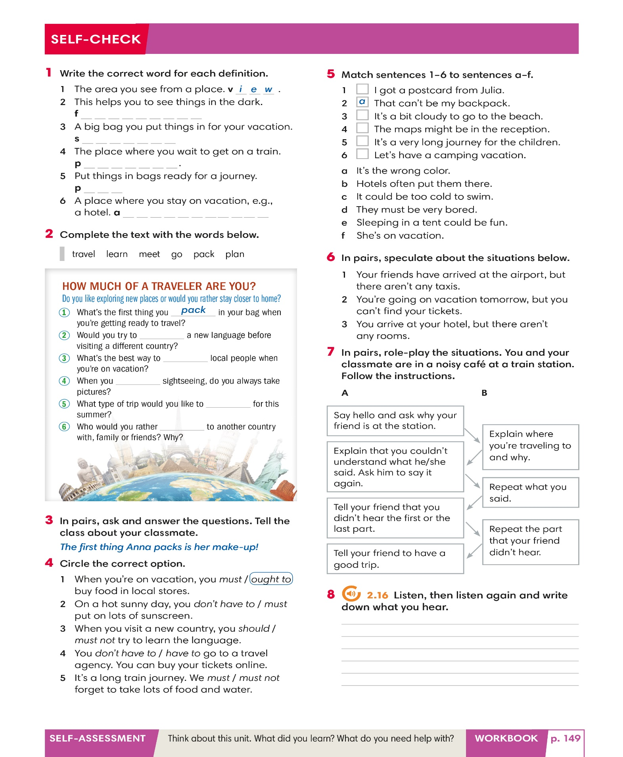

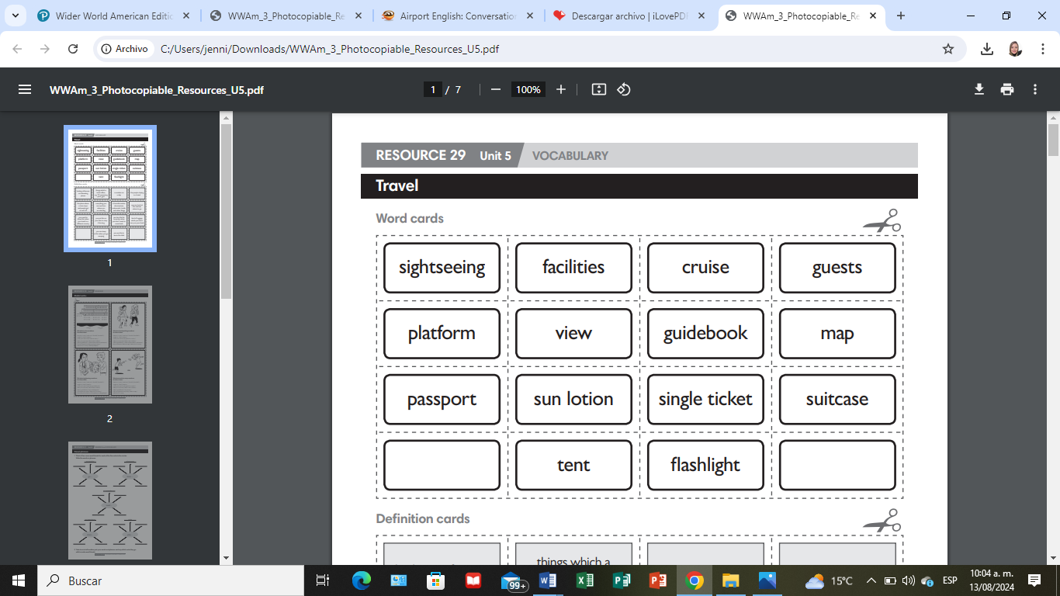

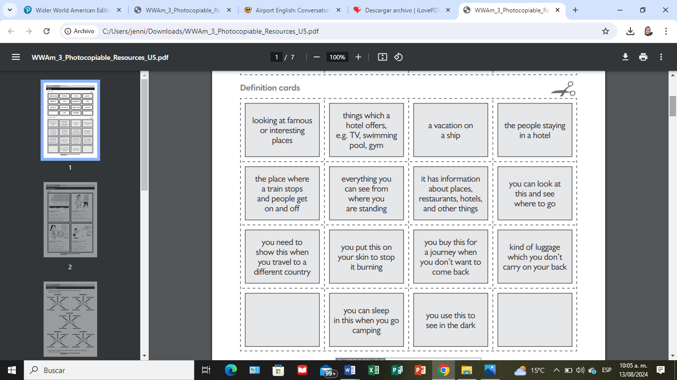

# Modal verbs

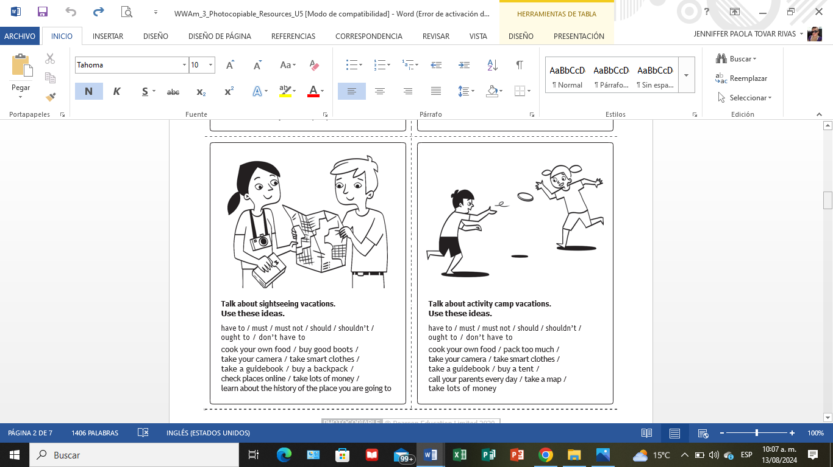

**Travel phrases**

## **1 Think of four more word friends for each of the five verbs in the circles. Write the words or phrases.**

*on vacation a language*

learn …

go …

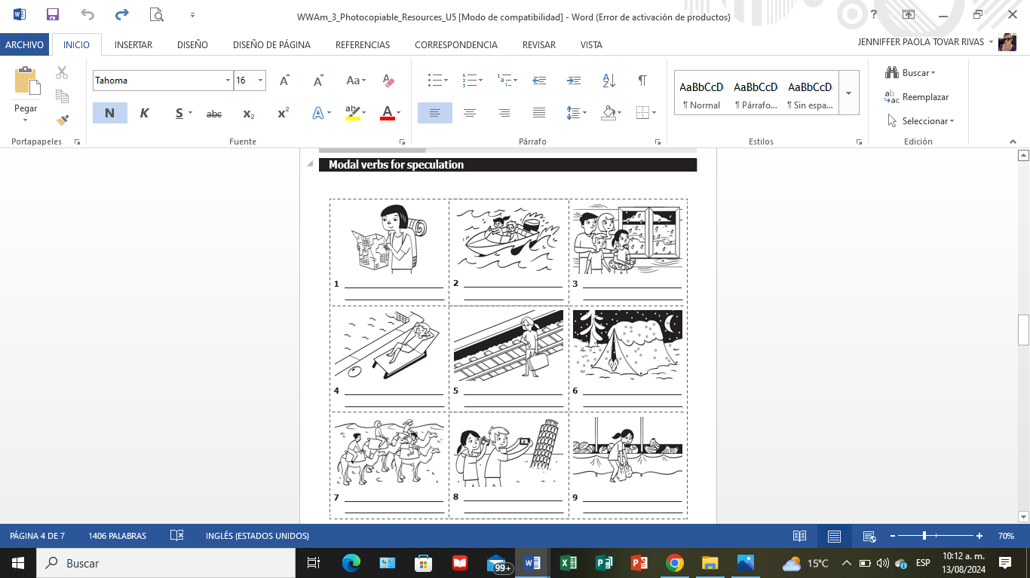

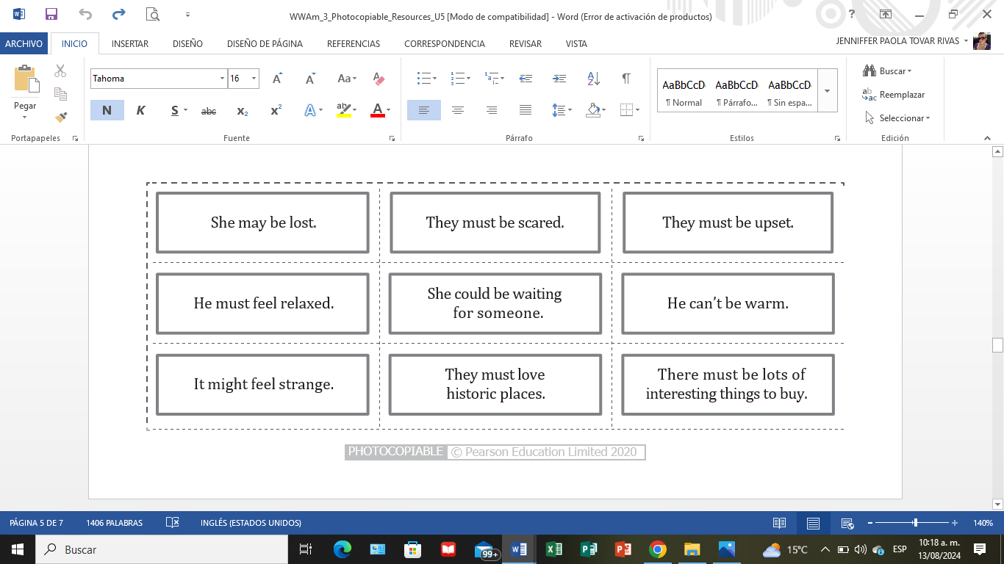

# Complete the blanks

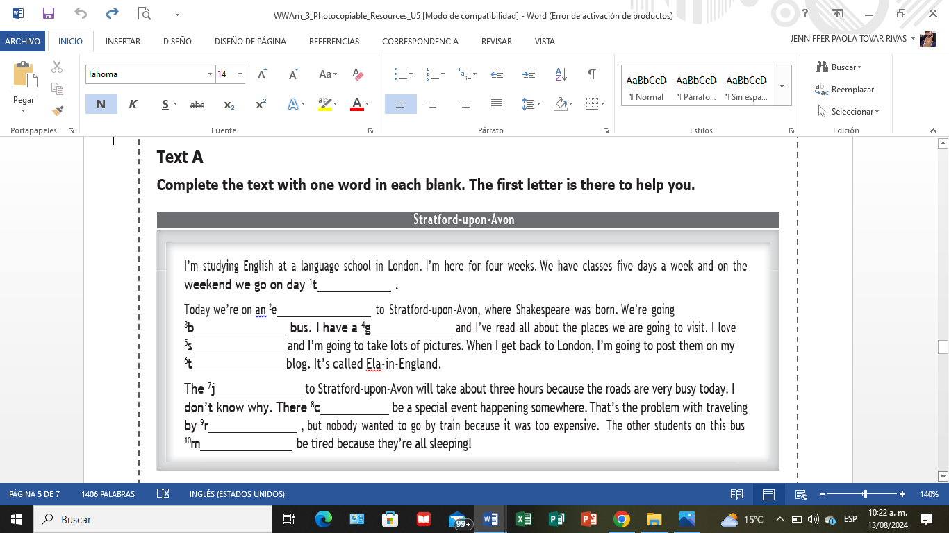

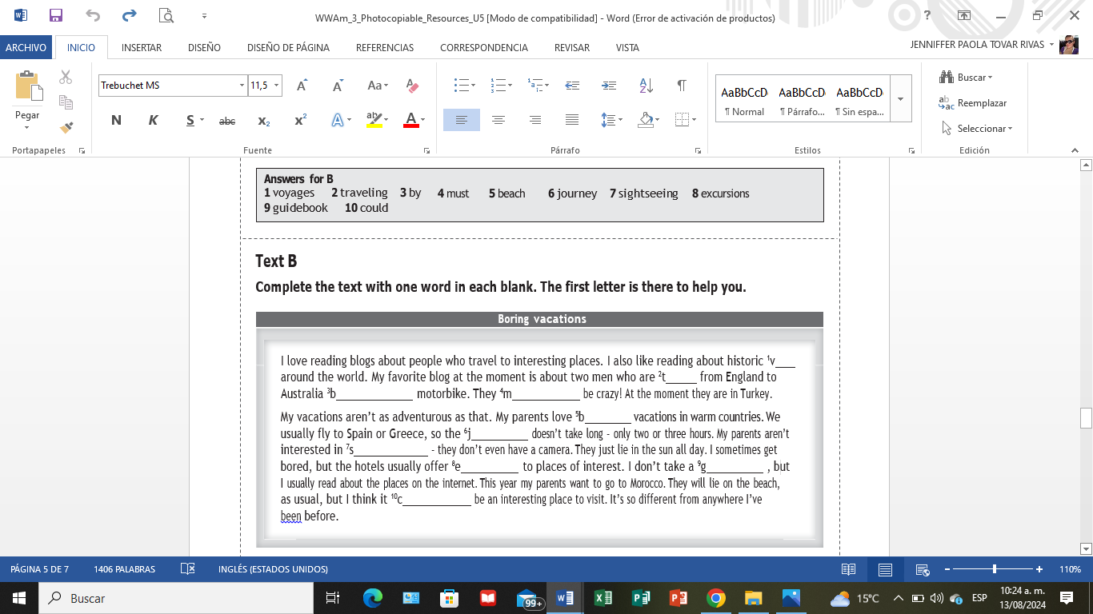

**Time clauses**

## **Use your imagination to complete the sentences.**

* 1. While we are waiting for our plane tomorrow, we .
  2. When we stop for lunch later, I .
  3. After I finish dinner, I .
  4. Before Tom goes on his activity camp, his parents .
  5. As soon as I know my test results, I .
  6. I won’t buy any vacation clothes until I .
  7. I’ll eat my sandwiches while .
  8. I’ll call you when .
  9. I’ll relax after .
  10. I won’t book the train tickets until .
  11. I’ll buy a guidebook before .
  12. I’ll meet you as soon as .

## **Imagine that you are discussing the summer vacation with your friend. Write a short dialogue. Use at least five words or phrases from the box.**

## **After as soon as before until when while will won’t**

**A:**

**B:**

**A:**

**B:**

**A:**

**B:**

**A:**

**B:**

**A:**

**B:**